# Towers of Hanoi Program

This program will allow the user to play the classic game The Towers of Hanoi.

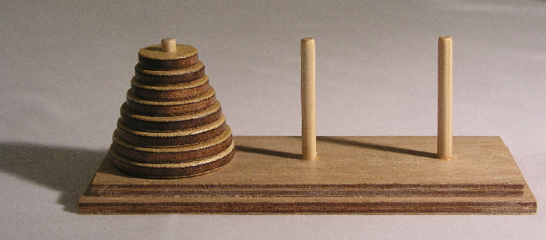

The object of the game is to move all of the disks from the first post onto the right post. The player may only move one disk at a time, and cannot place a disk on top of a smaller one. Implement the posts as three stacks of integers, and use the numbers 1 through 8 to represent the disks. A possible screen shot to represent the above board position would look like this:

| | |

1 | |

22 | |

333 | |

4444 | |

55555 | |

666666 | |

7777777 | |

88888888 | |

# Required Function: CheckWin

This function takes the third stack for an argument, and returns a number that indicates success or failure. This function prints nothing to the screen.

# Required Function: InitiBoard

This function initializes the board to have the first stack full of disks 1-8 and the other stacks are empty. It also resets the moves counter to zero.

# Required Function: Move

This function takes two stacks as an argument. It must peek each stack to see if it is legal to move from the first stack to the second, and if it is not legal, it must return an integer to indicate an illegal move. If the first stack is empty, an error code should also be generated. If everything is ok, simply pop from the first stack and push that value onto the second stack.

# Notes

The program needs to display an error messages appropriate to each type of error.

The program must keep track of the number of moves used to solve the puzzle and display it

when completed.

The program should loop to allow replaying.

The program must be well-commented.

The program must be printed out and turned in with this paper attached. (THIS SIDE UP)

Towers of Hanoi Program Name ___________________

|  |  |  |
| --- | --- | --- |
| Criteria | Points Possible | Points Earned |
| Game correctly checks for a win | 25 |  |
| Game correctly avoids illegal moves | 25 |  |
| Game resets when looped | 15 |  |
| Game counts the number of moves and displays it after a win | 15 |  |
| Game is displayed clearly | 15 |  |
| Commented | 5 |  |
| Late | -5 points per day late |  |
| Total: | 100 |  |